**DAILY ONLINE ACTIVITIES SUMMARY**

|  |  |  |  |  |  |  |  |  |
| --- | --- | --- | --- | --- | --- | --- | --- | --- |
| **Date:** | **06-07-2020** | | | | | **Name:** | **Shiza Amreen.J** | |
| **Sem & Sec** | **4th Sem B Sec** | | | | | **USN:** | **4AL18CS078** | |
| **Online Test Summary** | | | | | | | | |
| **Subject** | | **18MAT41** | | | | | | |
| **Max. Marks** | | **--** | | **Score** | | | **--** | |
| **Certification Course Summary** | | | | | | | | |
| **Course** | **Introduction to R** | | | | | | | |
| **Certificate Provider** | | | **GreatLearning** | | **Duration** | | | **3 Hours** |
| **Coding Challenges** | | | | | | | | |
| **Problem Statement:** [**Write a Java program to find the Nth natural number with exactly two bits set**](https://github.com/orgs/alvas-education-foundation/teams/2nd-year/discussions/146) | | | | | | | | |
| **Status: Completed** | | | | | | | | |
| **Uploaded the report in Github** | | | | | **Yes** | | | |
| **If yes Repository name** | | | | | **Lockdown_coding**  <https://github.com/ShizaAmreen/Lockdown_coding> | | | |
| **Uploaded the report in slack** | | | | | **Yes** | | | |

Online Test Details:

Today we had 18MAT41 Descriptive Test – 1, I have attended the test and uploaded the scanned copy in Google Classroom.

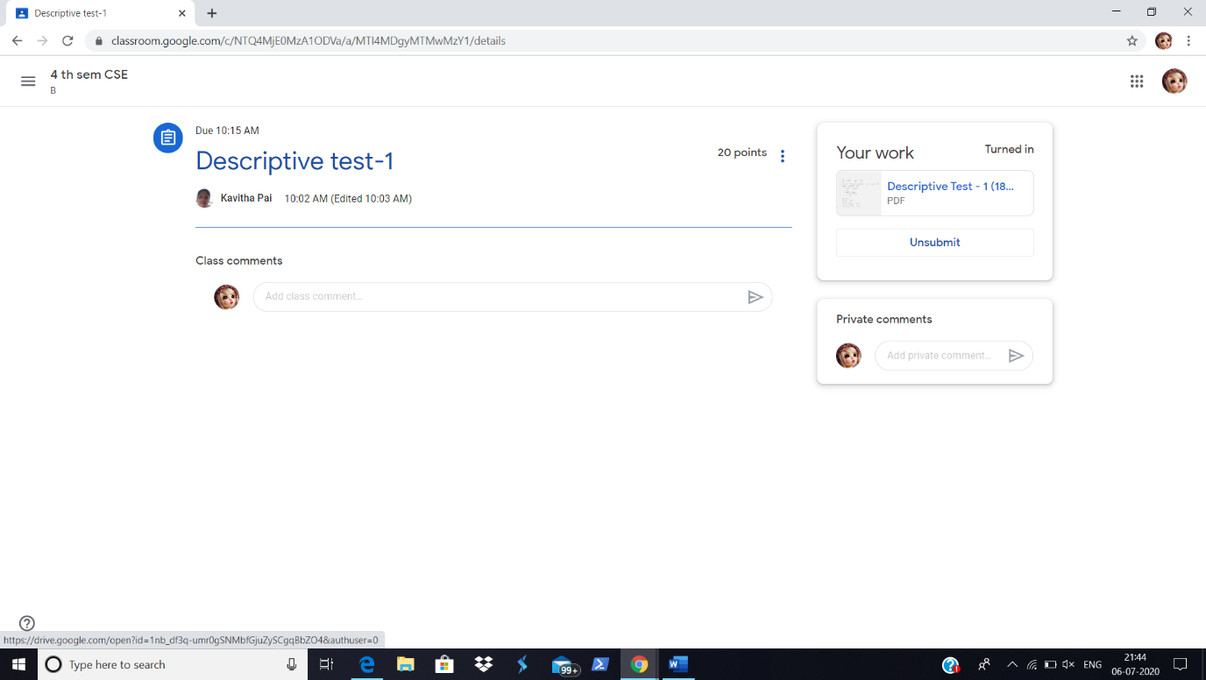

Certification Course Details:

Today I attended the Quiz-2, and got 8 out of 10, which is eligible fo getting the certificate, at the end of the course.

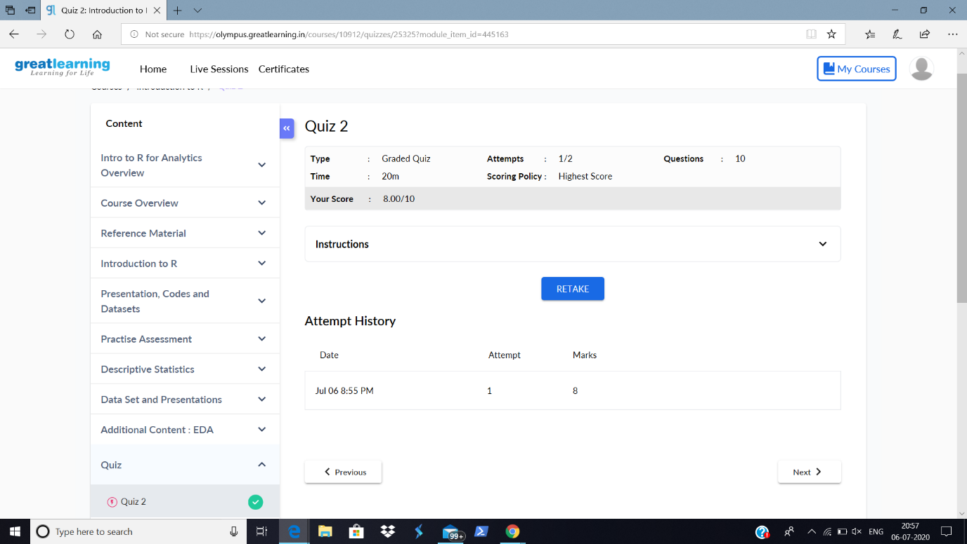

Coding Challenges Details:

|  |
| --- |
| **Problem Statement:** [**Write a Java program to find the Nth natural number with exactly two bits set**](https://github.com/orgs/alvas-education-foundation/teams/2nd-year/discussions/146) |

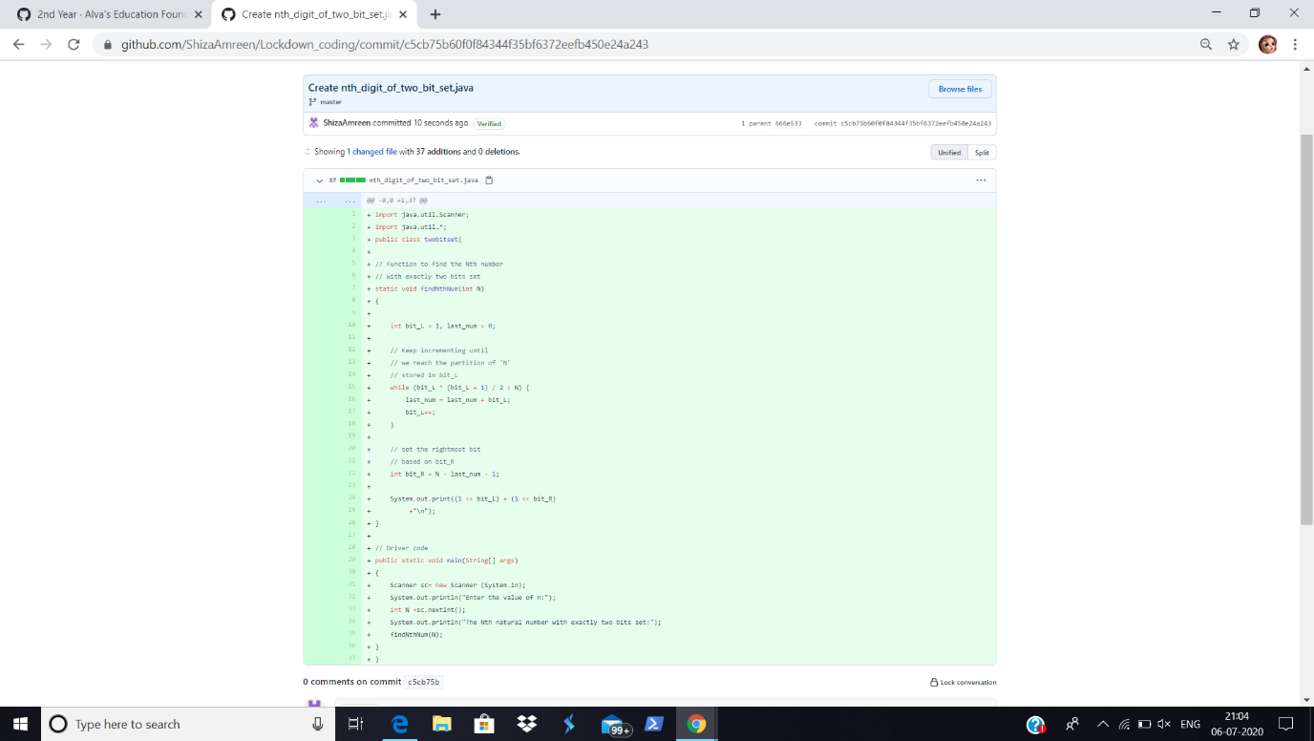

**I have written the code for given problem statement and uploaded it in my github repository, Lockdown_coding.**

<https://github.com/ShizaAmreen/Lockdown_coding/commit/c5cb75b60f0f84344f35bf6372eefb450e24a243>